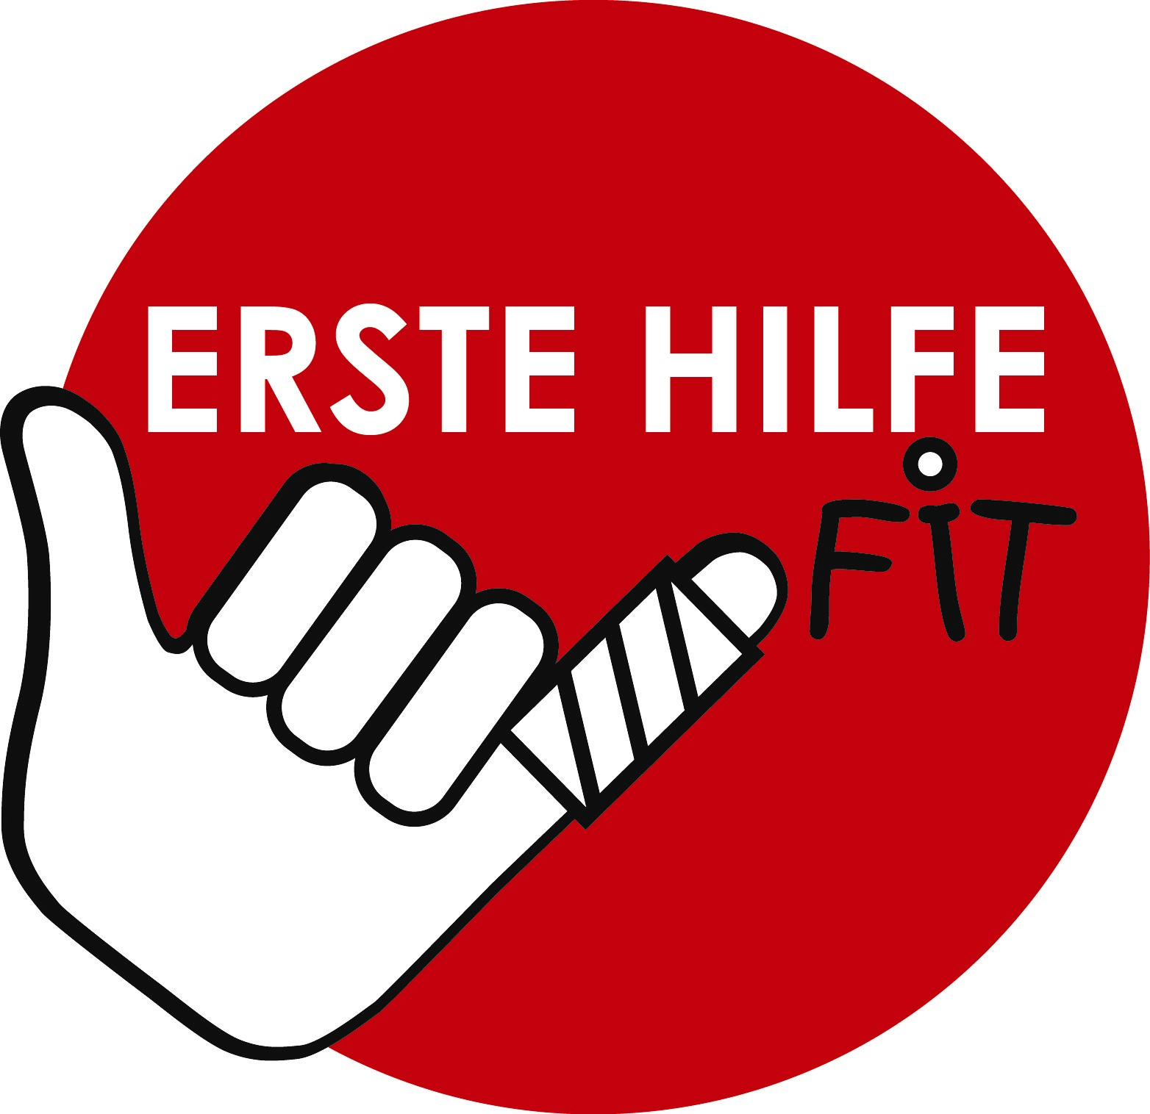
Our school turns
FIRST AID FIT!

Dear Parents!

Let us ask you a personal question: How familiar are you with first aid?
At some point in your life you probably already have completed a first aid course.
Do you remember when that was? Could you help in an emergency?

We, the teaching staff of your child's school, have intensively dealt with this question. What happens in an emergency situation when seconds count? Does everyone know what to do? Are the responsible authorities and the contact persons known? Is our school prepared to react correctly in an emergency?

We have decided to make our school even safer. Everyone should know what first aid is and what to do when there is need for it. Who should be informed? Where is the first aid kit? All students should have the opportunity to train their knowledge with the help of age-appropriate offers.

Our school wishes to achieve the seal of approval "ERSTE HILFE FIT", which is awarded by the Austrian Youth Red Cross, AUVA and the Ministry of Education.

With this seal we increase the overall safety in our school and the competence of all people who are in the school – including teachers, other school staff and of course all students who attend our school.

If you are interested, you can find more detailed information about the programme online at www.erstehilfefit.at. We will keep you informed about our way to obtain he "FIRST HELP FIT" certificate!

